# Project Plan

## S.A.K

Document version 1.6

Written by *Super Action Knight*

Point of contact: Kim Dong Hyun*(kdh09@ajou.ac.kr)*

2021.5.14

## Group members

|  |  |  |
| --- | --- | --- |
| **Name** | **Role** | **Main contributions** |
| Kim Dong Jun | Developer | Request implementation(main), UI |
| Kim Dong Hyun | Leader | Server, DB, Request implementation |
| Lee Woo Hyun | Developer | Client side implementation, UI, Game logic |

## Document history

|  |  |  |  |
| --- | --- | --- | --- |
| **Revision** | **Date** | **Name** | **Comment** |
| 1.0 | 2021.4.2 | KDH, KDJ, LWH | GDD update, targeting users etc. |
| 1.1 | 2021.4.8 | KDH, KDJ, LWH | Product backlog update |
| 1.2 | 2021.4.15 | KDH, KDJ, LWH | Product backlog update |
| 1.3 | 2021.5.9 | KDH, KDJ, LWH | Product backlog update |
| 1.4 | 2021.5.21 | KDH, KDJ, LWH | Product backlog update |
| 1.5 | 2021.5.27 | KDH, KDJ, LWH | Beta Version |
| 2.0 | 2021.6.9 | KDH, KDJ, LWH | Final Version |

# Idea description and motivation

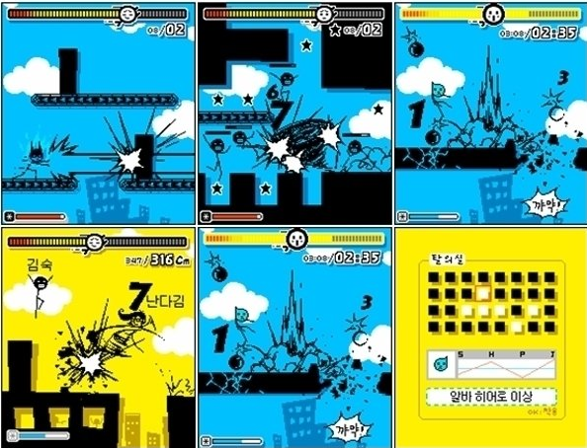

*We were inspired by the feature phone game called ‘Super Action Heroes’, a game that came out when we were kids. We got the idea from the stage that player breaks down as many walls as possible. Similarly, we will create a game where players break walls and avoid them as much as possible to get a better score for each gameplay.*

# Product Backlog

***<Top priority backlog>***

***-2021.4.8-***

*• User character’s movement*

*• User character’s attack*

*• User character’s ultimate skill*

*• Enemy features*

*• Obstacle features*

***-2021.4.15-***

***<Client side priority>***

*• User character’s movement – up/down touch (screen split), action buttons on the right-side screen.*

*• User fever time.*

*• User character’s attack (for scoring).*

*• User character’s ultimate skill*

*• Enemy features*

*• Effect*

***<Server side priority>***

*• log in handling*

*• player score*

*• saving player’s coin / player’s item / player’s companion(pet)*

***-2021.5.9-***

***<Client side priority>***

*• Enemy features (How to spawn Enemy)*

*=> Reference :https://gall.dcinside.com/mgallery/board/view/?id=game_dev&no=39273*

*• UI Design*

*• Level Design(How much score the player get, price of box(spawn companion), or other item, inclination of level during in game, player leave longer, level is harder)*

*• Companion*

*• Map and character design (Still Find asset...).*

*• Other Scene Design(Mainmenu, after game, login….)*

*• Effect And Sound*

*• Character, enemy Feature update*

***<Server side priority>***

*• Split DB table as follows ->*

*• User information : ID(DB id)(PK) / username(nick name)(FK) / email / password / user_client-version*

*• Player in-game info : username(PK) / Player score / coin / player’s companion(pet)*

*• Controller implementation*

*• Client-side request implementation - UNITY side request*

***-2021.5.21-***

*<Client side priority>*

*• Ingame UI => make HP Bar*

*• Level Design(How much score the player get, price of box(spawn companion), or other item, inclination of level during in game, player leave longer, level is harder)*

*• scoring -> Default scoring ( score += 50 per 2 sec etc.) / On destroy enemy: +300*

*• coin -> After game over, player get coins depending on his or her score*

*• combo -> combo % 50 => fever mode.*

*• Documentation*

*• Fly enemy, obstacle asset.*

*• Companion*

*<Server side priority>*

*• Implement companion DB table*

*• Implement spring server’s controller, service bean, repository for companion data handling*

***-2021.6.4-***

*• Add unimplemented UI features etc.*

*• Final finishing work*

*• Fixing bugs*

*• Preparing Final milestone*

**Schedule and work division**

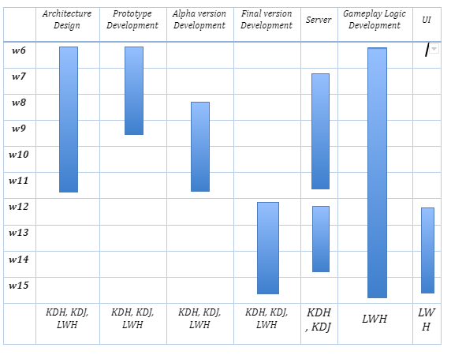

# Collaboration plan

*• Communication tools: Zoom, KakaTalk, discord*

*• Work sharing tools: Git, Google docs, draw.io(diagram)*

As we use scrum model, we will meet shortly on daily scrum meetings everyday if it is possible. This daily scrum meeting is not for discussion about complex content, but we’re just going to take a turn to talk about what features have been implemented. And for each end of the week sprint, we will discuss longer during the lab session.